**Excel Assignment - 11**

1. **Use the below table for the following Questions.**

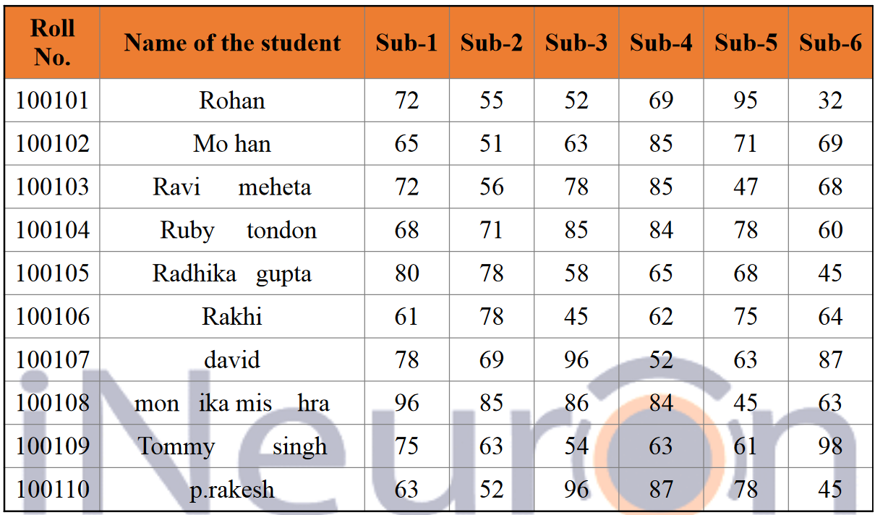

**1. Find the Minimum Marks and Maximum marks scored by each student.**

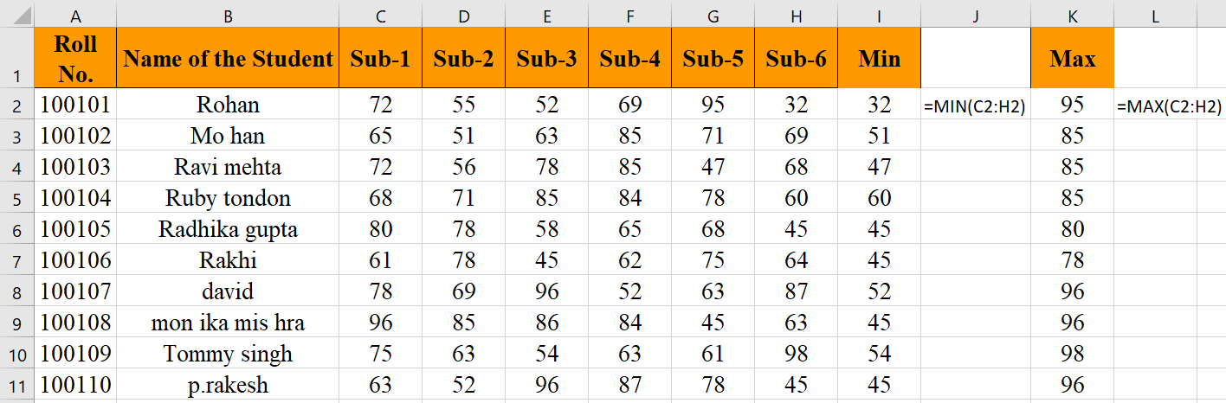

**2. Calculate the totals for each student, use conditional formatting to**

**highlight the top students who have scored more than 480.**

Since there were no student who scored more than 480, I did the conditional formatting based on the score of 420.

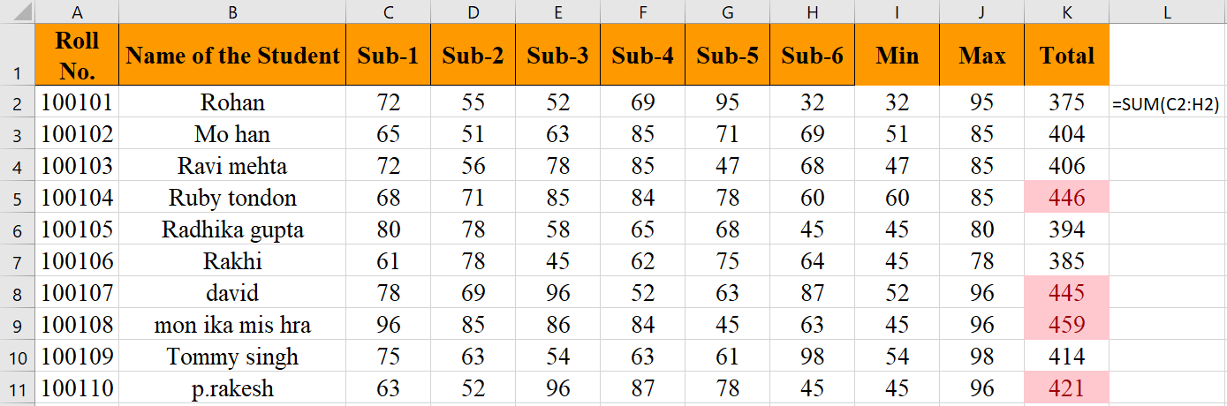

**3. Calculate the length of the names of each student.**

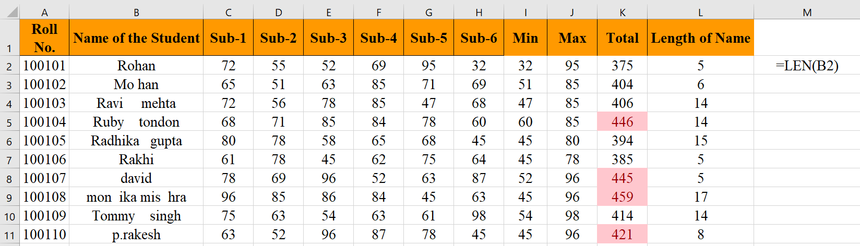

**4. Replace the Name Rakhi with Rocky. Use Formulas**

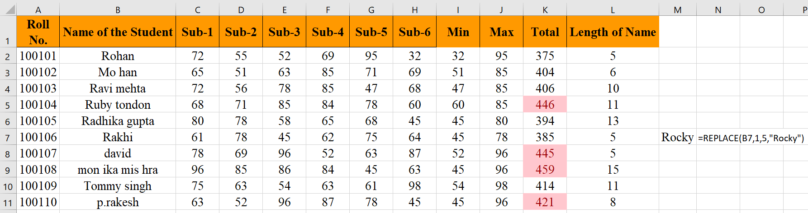

**5. Combine the Roll Numbers and Names. Use formulas. The end result**

**should look like below.**

**100101Rohan**

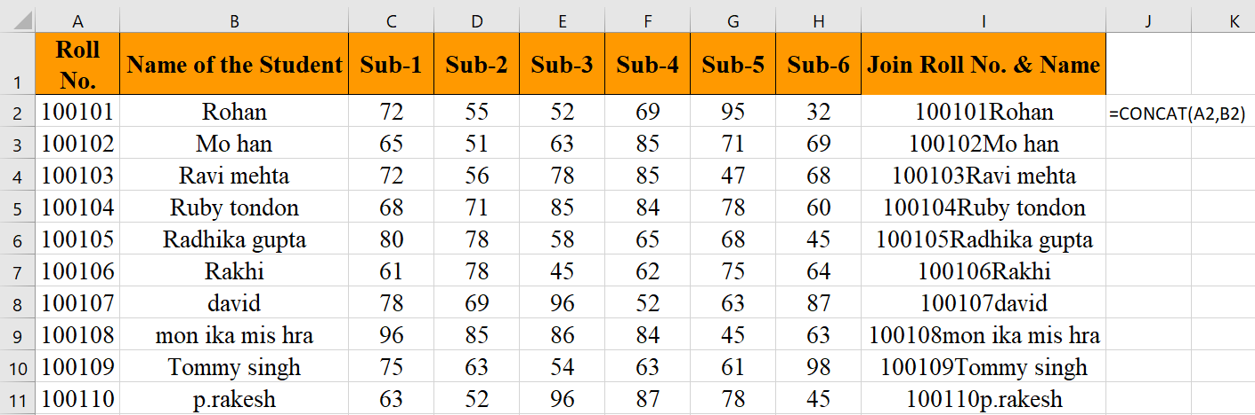

**6. As you can see that some names have spacing issues. Use Formulas**

**to correct that spacing. Also ensure that the names and surnames start**

**with a capital letter**

